**Lake Region State College Earn and Learn Apprenticeship Program Overview**

**What is an Apprenticeship**

Modern Apprenticeships build a highly skilled and customized flow of talent by preparing workers who typically stay around for the long term. Building upon the Career and Technical Education platform, it organizes classroom and work-based learning around knowledge and skills that specific occupations demand and offers deeper and more extensive on-the-job training or on- the job – learning.

For students it creates a clear pathway to employment through a structured work-based learning program and builds interpersonal and technical skill sets through a sophisticated workplace experience.

**THE PATH**: President’s Commission on Apprenticeships —Apprenticeship programs, when implemented effectively, provide workers with a career path featuring paid on-the-job training, skills development, and mentorship, while at the same time providing employers with a steady source of highly trained and productive workers. The LRSC Earn and Learn Apprenticeship Program collaborates with both newcomers to the field or seasoned employees looking to upgrade and specialize in their skills.

**CORE CURRICULUM**: The core of our curriculum is built on a broad foundation of industry-relevant concepts adapted for use in the courses to give students hands-on experience, allowing students to transition easily from class to work and back. The program and curriculum content are built with each industry partner in mind and align with the job skills. We train to meet your career goals!

**INTERACTIVE COURSEWORK**: The interactive coursework covers the analytical and technical skills necessary to monitor and respond to situations that arise. Our curriculum aligns with industry-standard certification-exam content, to prepare an individual to pass exams from industry leaders. At the end of the apprenticeship program, students gain both experience in the profession as well as an Associate of Applied Science Degree in their chosen field.

**DONE IN 2**: LRSC’s Apprenticeship Program is designed as a two- to three-year program in partnership with employers. Students are assigned a mentor at their employer to work with throughout the program. LRSC offers apprenticeship and mentor coaching as a distinct part of program management. The curriculum is delivered online or at the worksite which makes it convenient for individuals to Earn & Learn. Academic credit is offered for qualified certifications and experience. The required technical courses are front-loaded so apprentices can rapidly advance their knowledge, skills, and competency.

**_________________________________________________________________**

Apprenticeship Program job openings are currently available on the college website <https://www.lrsc.edu/academics/programs/apprenticeship-program>. If you are a student and investigating apprenticeships, start with contacting

Melana Howe, the LRSC Apprenticeship Coordinator at [Melana.Howe@lrsc.edu](mailto:Melana.Howe@lrsc.edu)

**__________________________________________________________________**

Every apprenticeship program is aligned with current academic certifications or degrees or industry certificates. Upon completion of the program the student apprentice will receive a federally recognized certificate of completion PLUS their diploma or certificate from the LRSC campus.

**Apprenticeships benefit Employers, Students and Colleges**

Apprenticeships are a Win-Win-Win initiative: for employers, students, and colleges.

***For the employer they will:***

* Build a talent pipeline of higher-skilled employees.
* Lower their costs of advertising and recruiting.
* Reduce turnover rates.
* Enhance employee loyalty and motivation.
* Can be used for recruiting or upskilling current employees.

***For the student they will:***

* Provide employment with an employer who invests in YOU.
* Provide firsthand experience under the guidance of an employer mentor.
* Eliminate school debt as the employer pays wages, fees, tuition, and books while the student is an apprentice.
* Provide career advancement opportunities.

***For the community college they will:***

* Provide a stronger relationship with local employers.
* Assist to fill empty classroom seats.
* Keep academic programs updated through integrating current work practices.

**There are differences between internships and apprentices.**

An internship and apprenticeships are both work-based learning programs, however there are distinct differences. A community college has the potential to leverage internships into apprenticeships.

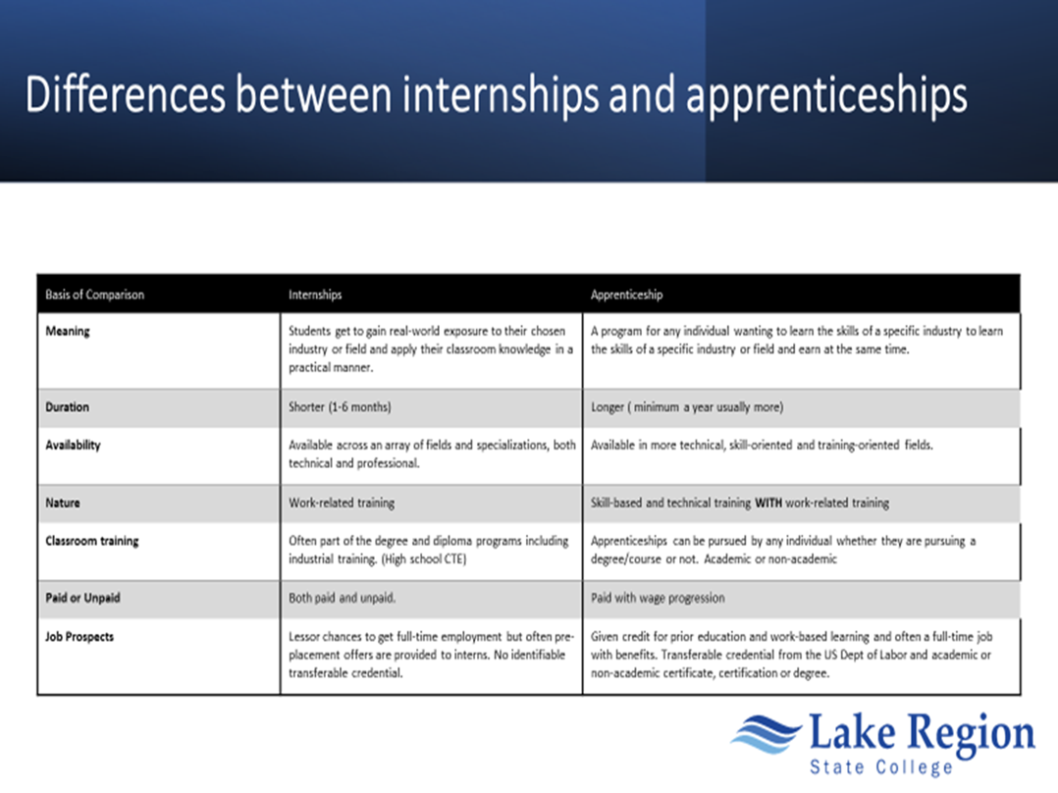

Registered Apprenticeships have been utilized to meet the needs of America’s skilled workforce for over 80 years. Registered apprenticeships are jobs where you ‘earn and learn.” While working on the job, you receive one-on-one , full-time training from a skilled staff member of the employer as well as related classroom instruction. These apprenticeship training programs are available in 1500 occupations across 170 industries found in businesses of all sizes and last from 1 – 5 years. Apprenticeship programs are for ambitious people of all ages who want to earn a salary while they learn, gaining real skills and knowledge. These programs offer employers the opportunity to strengthen and build their workforce providing a tailored high-quality talent pipeline. In this regard, Registered Apprenticeship programs effectively meet the needs of both employers and jobseekers.

Registered apprenticeship (RA) programs must have at least 144 hours of related technical instruction (RTI) and a minimum of 2000 hours of work-based-learning (WBL) or on the job training (OJT).

There are three types of apprenticeship program designs. The first is time based. The most common example is the plumbing or electrical apprenticeship where it requires four thousand or up to eight thousand hours of WBL. The second design is a competency based apprenticeship where the minimum number of hours is two thousand. The third is the hybrid design, which is a combination of the first two designs. Most apprenticeships are moving toward competency-based design. All require 144 hours of RTI.

**Other Requirements**



**High Schools credits**

Students who have had some exposure to the industry in an internship are more likely to be successful in apprenticeship. Companies who have hired interns can then hire a student who fits best with their company as an apprentice. The program is open to anyone 18 years or older at the time classes begin. However, juniors and seniors in high school can obtain college credits with dual credit classes to begin their pre-apprenticeship program. Anyone over 16 years of age and not currently in high school can also become an apprentice if pre-requisites are met.

Lake Region State College encourages companies who are not ready to hire an apprentice to engage with their local high schools to start an internship program and works with ND High Schools with preparing students in pre-apprenticeship coursework, so the individual already has job expertise and is able to work immediately upon hire. Let’s work together!

***T***he apprenticeship programs are open to all ages (16 years and above) and backgrounds. Students can be career changers, veterans, unemployed, under-employed, or recent high school or GED graduates. Companies are also welcomed to bring their own employees into the program to advance a valuable employee’s career path. Students may be able to enroll in an apprenticeship program and complete the entire program in their current location. Some programs require the individual to be on campus for some components of their program in which case they are responsible for their own travel and accommodations while attending the program.

**Pathways to Academic Degrees**

Apprentices earn a wage, gain job experience, and have a foot in the door with an employer before graduating from the program. Also, depending on the company, you may be eligible for company benefits such as health care and vacation. Finally, as part of an apprenticeship program, students earn a wage increase (at least annually) as their skills and knowledge develop. The cost to the student varies depending on the company or industry partner, however most employers will cover all or most of the costs.

The LRSC Earn and Learn program is unique because while completing the apprenticeship requirements, all the training and education you receive while in the program also qualifies you for an academic degree through LRSC and is transferable to other universities if you choose to continue your education. LRSC apprenticeship programs are AAS degrees with at least sixty-five credit hours meaning students can transfer in at junior status. The programs vary in length between 2 and 3 years with students attending college in the fall and spring semester.

Colleges can provide RTI several ways:

1. Employers can state they have an apprentice but not an RA program and can enroll a student in any college course.
2. Employers have their own RA program (the company is a sponsor) where the tax college provides the RTI which can be a single course, multiple courses, or join the college’s RA program.
3. Employers can collaborate with an intermediary providing the RTI which can be a course, multiple courses, or join the college’s RA program.
4. A college can be an RA program sponsor, where the college is an intermediary or connector, linking employers with potential apprentices, **PLUS** providing the RTI.

**Mentorship**

The U.S. Department of Labor requires every of an apprentice to actively participate in a mentorship program. LRSC will train all mentors as part of the onboarding process of the company. Mentors are apprentice coaches and support the student apprentice in their work-based-learning. They are role models, encouragers, and positive thinkers. LRSC provides a one hour training session for all employer mentors. Mentors spend time with the apprentices during work time to discuss their progress and converse about any issues or concerns. Mentors are personal cheerleaders and can become life-long professional colleagues and friends.

**The student schedules**

The students’ academic courses change very minimally. Depending on the job role or job description, the employer may suggest the student apprentice take certain courses to prepare them for their work environment. It is not particularly desirable to have the student apprentice work more than 20-32 hours a week while in school. Of course, this guideline depends on the particular courses taken during the semester or term. To overburden a student with heavy course load and full-time or mandatory overtime in the work schedule does not benefit anyone and the student will fail their courses, quit their job or both.

**Employer expectations**

The employer’s expectation is to employ an apprentice and see the pleasures of long-term employment of a competent and highly skilled employee for years. Investing in an individual as an apprentice takes time, effort, and funds. In response, the apprentice is an excellent employee by expressing interest in their job, is skillful and competent and understands social and cultural expectations of the workplace.